Communication is the Key

Find out why communication is important. Explore how different leaders communicate ideas to different groups to reach their audience.

Section A: Why is Communication Important?

Everyone has felt frustrated before by miscommunications or where others didn’t understand the message trying to be communicated. Effective communication occurs only when the receiver understands the exact information that the sender is trying to transmit. A leader must be a good speaker and a writer as well as a good listener in order to get things accomplished.

Task #1:

Watch the Julius Chambers Leadership Strategy clip to learn about how listening helped the Civil Rights Movement students.

Enter Response here:

Task #2:

What might have happened if the leaders had not stopped to listen to the students?

Enter Response here:

Section B: What is Effective Communication?

Effective communication occurs when the receiver understands the information and gives the sender verbal and non-verbal clues that the message is understood.

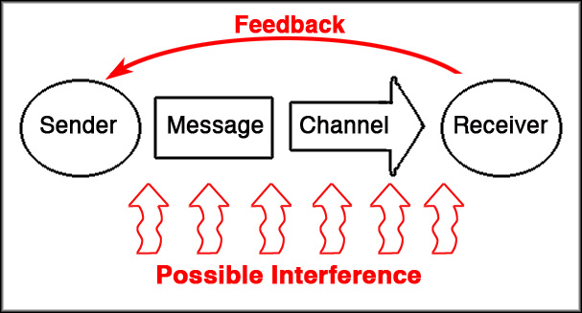

There are many places where barriers can interfere with the communication of the message. The sender may not make the message very clear, may choose a bad channel for conveying the information, or try to communicate in a way the receiver can not understand. The receiver's verbal and non-verbal feedback is very important to ensure that the message was communicated correctly.

Task #3:

Think of a situation in your life where there was a barrier to communication. Did you send the wrong message? Was the message sent the wrong way or at the wrong time or place? Briefly write about the situation and about how the barrier could have been eliminated.
Enter Response here:

Section C: How Do Leaders Communicate Ideas?

In the video clips provided, two Black leaders talk about presentation styles. Watch the clips and answer the questions below:

Task #4:

Julius Chambers talks about different speaking styles in Leadership Styles. Write down how each speaker mentioned in the clip uses style to engage the audience.

Enter Response here:

Task #5:

In the video clip Leadership: Black Leadership, Mary Futrell talks about how she changed her speaking style after some feedback from her peers. Write about what happened in the situation and what she learned.

Enter Response here:

Section D: How do Leaders Speak to Different Groups?

You might have the best idea in the world, but no one will ever find out about it if you cannot communicate your ideas clearly to different groups of people.

Task #6:

Watch each of the video clips where the Black leaders talk about reaching different audiences. What strategies does each leader use to tailor the style to different audiences?

Enter Response here:

Section E: Code Switching

There are many groups of people who you interact with everyday such as teachers, family members, store clerks, neighbors, other students, and friends. Many people switch the way they speak depending on who they are talking to. They might use slang with their friends and classmates and use a more formal way of talking with teachers and other adults. Anthropologists call this code-switching. People who are able to code-switch are often very successful communicators because they can present information in a way the group they are talking with will understand.

Task #7:

Are you a code-switcher? How do you address different groups differently? Write about at least one instance when you used code switching to your advantage or to your disadvantage.
Enter Response here:

Discussion Question:

Many of the Black leaders above use different speaking styles when addressing an audience that is mainly black or mainly white. Several mention that their message stays the same, but their style changes. Some people might consider this being false or being 'two-faced.' Others might argue that the ability to code-switch has helped these leaders be successful. What do you think? Write down your ideas and be able to support your perspective in a group discussion

Enter Response here:

